**IB MATH STUDIES EXAM REVIEW: Topic 7**

**Rates of Change, Derivatives, Equations of Tangent and Normal Lines, Stationary Points, Increasing and Decreasing Intervals, The Second Derivative, Maxima and Minima, Optimization Problems**

**1.** The figure shows the graphs of the functions *f*(*x*)= *x*2 – 2 and *g*(*x*)= *x*.

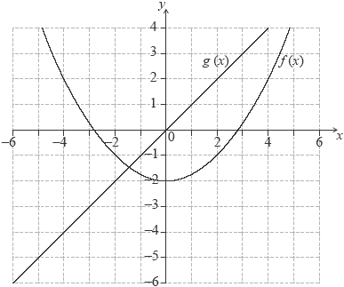

(a) Differentiate *f*(*x*)with respect to *x.*

(1)

(b) Differentiate *g*(*x*)with respect to *x.*

(1)

(c) Calculate the value of *x* for which the gradients of the two graphs are the same.

(2)

(d) Draw the tangent to the parabola at the point with the value of *x* found in part (c).

(2)

(Total 6 marks)

**2.** The curve *y* = *px*2 + *qx* – 4 passes through the point (2, –10).

(a) Use the above information to write down an equation in *p* and *q*.

(2)

The gradient of the curve *y* = *px*2 + *qx* – 4 at the point (2, –10) is 1.

(b) (i) Find .

(ii) Hence, find a second equation in *p* and *q*.

(3)

(c) Solve the equations to find the value of *p* and of *q*.

(3)

(Total 8 marks)

**3.** The table given below describes the behaviour of *f*′(*x*), the derivative function of *f*(*x*), in the domain –4 < *x* < 2*.*

|  |  |
| --- | --- |
| ***x*** | ***f*′(*x*)** |
| –4 < *x* < –2 | < 0 |
| –2 | 0 |
| –2 < *x* < 1 | > 0 |
| 1 | 0 |
| 1 < *x* < 2 | > 0 |

(a) State whether *f*(0) is greater than, less than or equal to *f*(–2). Give a reason for your answer.

(2)

The point P(–2, 3) lies on the graph of *f*(*x*).

(b) Write down the equation of the tangent to the graph of *f*(*x*) at the point P.

(2)

(c) From the information given about *f*′(*x*), state whether the point (–2, 3) is a maximum, a minimum or neither. Give a reason for your answer.

(2)

(Total 6 marks)

**4.** Let *f*(*x*) = 2*x*2 + *x* – 6

(a) Find *f*′(*x*).

(3)

(b) Find the value of *f*′(–3).

(1)

(c) Find the value of *x* for which *f*′(*x*) = 0.

(2)

(Total 6 marks)

**5.** Consider *f* : *x*  *x*2 – 4.

(a) Find *f*′(*x*).

(1)

Let *L* be the line with equation *y* = 3*x* + 2.

(b) Write down the gradient of a line parallel to *L*.

(1)

(c) Let P be a point on the curve of *f*. At P, the tangent to the curve is parallel to *L*.  
Find the coordinates of P.

(4)

(Total 6 marks)

**6.** The straight line, *L*, has equation 2*y* – 27*x* – 9 = 0.

(a) Find the gradient of *L*.

(2)

Sarah wishes to draw the tangent to *f*(*x*) = *x*4 parallel to *L*.

(b) Write down *f*′(*x*).

(1)

(c) (i) Find the *x-*coordinate of the point at which the tangent must be drawn.

(ii) Write down the value of *f*(*x*) at this point.

(3)

(Total 6 marks)

**7.** The diagram shows a sketch of the function *f*(*x*) = 4*x*3 – 9*x*2 – 12*x* + 3.

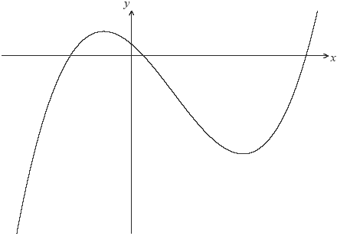

(a) Write down the values of *x* where the graph of *f*(*x*) intersects the *x-*axis.

(3)

(b) Write down *f*′(*x*).

(3)

(c) Find the value of the local maximum of *y* = *f*(*x*).

(4)

Let P be the point where the graph of *f*(*x*) intersects the *y-*axis.

(d) Write down the coordinates of P.

(1)

(e) Find the gradient of the curve at P.

(2)

The line, *L*, is the tangent to the graph of *f*(*x*) at P.

(f) Find the equation of *L* in the form *y* = *mx* + *c*.

(2)

There is a second point, Q, on the curve at which the tangent to *f*(*x*) is parallel to *L*.

(g) Write down the gradient of the tangent at Q.

(1)

(h) Calculate the *x*-coordinate of Q.

(3)

(Total 19 marks)

**8.** A dog food manufacturer has to cut production costs by using as little aluminum as possible in the construction of cylindrical cans. In the following diagram, *h* represents the height of the can in cm, and *x* represents the radius of the base of the can in cm.

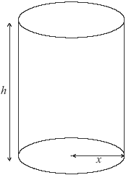

The volume of the dog food cans is 600 cm3.

(a) Show that *h* = .

(2)

(b) (i) Find an expression for the curved surface area of the can, in terms of *x*. Simplify your answer.

(ii) Hence write down an expression for *A*, the total surface area of the can, in terms of *x*.

(4)

(c) Differentiate *A* in terms of *x*.

(3)

(d) Find the value of *x* that makes *A* a minimum.

(3)

(e) Calculate the minimum total surface area of the dog food can.

(2)

(Total 14 marks)

**9.** Consider the function *f*(*x*) = 3*x* + , *x* ≠ 0.

(a) Differentiate *f*(*x*) with respect to *x*.

(3)

(b) Calculate *f*′(*x*) when *x* = 1.

(2)

(c) Use your answer to part (b) to decide whether *f*(*x*) is increasing or decreasing at *x* = 1. Justify your answer.

(2)

(d) Solve the equation *f*′(*x*) = 0.

(3)

(e) The graph of *f* has a local minimum at point P. Let *T* be the tangent to the graph of *f* at P.

(i) Write down the coordinates of P.

(ii) Write down the gradient of *T*.

(iii) Write down the equation of *T*.

(5)

(f) Sketch the graph of the function *f*, for –3 ≤ *x* ≤6 and –7 ≤ *y* ≤ 15. Indicate clearly the point P and any intercepts of the curve with the axes.

(4)

(g) (i) On your graph draw and label the tangent *T*.

(ii) *T* intersects the graph of *f* at a second point. Write down the *x*-coordinate of this point of intersection.

(3)

(Total 22 marks)

**10.** Consider the function *y = x*2 – 7*x* – 44.

(a) Find the equation of the normal at the point where *x* = –3.

(7)

(b) Find the coordinates of the point where the normal meets the curve again.

(3)

(Total 10 marks)

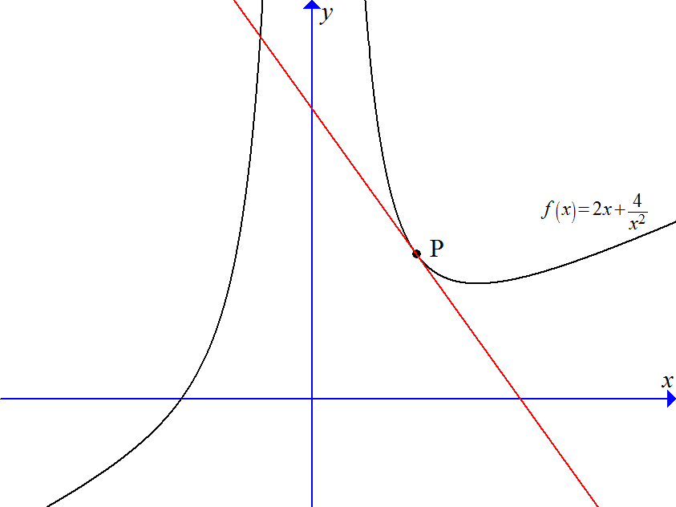**11.** Consider the function .

(a) Find *f*′(*x*).

(2)

(b) The tangent to *f*(*x*) at point P has a gradient of –6. Find the coordinates of point P.

(5)

(c) Find the equation of the tangent at point P.

(1)

(d) Find where the tangent cuts the *x*-axis.

(2)

(e) Find the equation of the normal at P, expressing your answer in the form *y* = *mx* + *b*.

(3)

(f) Find the coordinates of both points at which the normal intersects *f*(*x*) again.

(5)

(Total 18 marks)