**IB MATH STUDIES EXAM REVIEW: Topic 6**

**Domain & Range, Linear Functions, Intercepts, Exponential Functions, Asymptotes, Quadratic Functions, Axis of Symmetry, Vertex, Other Functions, Maxima & Minima, Endpoints, Intersections, Accurate Graphs**

**1.** The graph of the quadratic function *f*(*x*) = 3+ 4*x* – *x*2 intersects the *y-*axis at point A and has its vertex at point B.

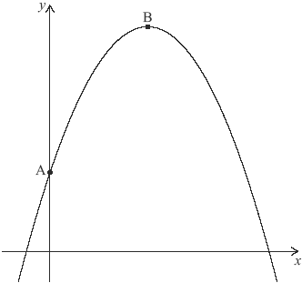

(a) Find the coordinates of B.

(3)

Another point, C, which lies on the graph of *y* = *f*(*x*) has the same *y-*coordinate as A.

(b) (i) Plot and label C on the graph above.

(ii) Find the *x-*coordinate of C.

(3)

(Total 6 marks)

**2.** Consider the function *f*(*x*) = 1.25 – *a*–*x*, where *a* is a positive constant and *x* ≥ 0. The diagram shows a sketch of the graph of *f.* The graph intersects the *y-*axis at point A and line *L* is its horizontal asymptote.

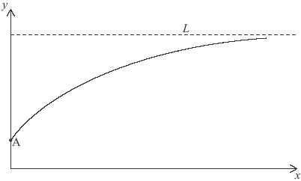

(a) Find the *y-*coordinate of A.

(2)

The point (2, 1) lies on the graph of *y* = *f*(*x*)

(b) Calculate the value of *a.*

(2)

(c) Write down the equation of *L.*

(2)

(Total 6 marks)

**3.** Consider the function *f*(*x*) = *p*(0.5)*x* + *q* where *p* and *q* are constants. The graph of *f*(*x*) passes through the points (0, 6) and (1, 4) and is shown below.

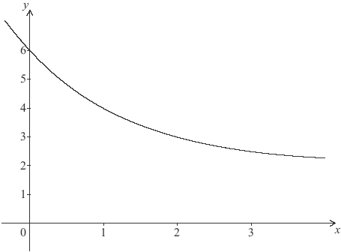

(a) Write down two equations relating *p* and *q*.

(2)

(b) Find the value of *p* and of *q*.

(2)

(c) Write down the equation of the horizontal asymptote to the graph of *f*(*x*).

(2)

(Total 6 marks)

**4.** The following is the graph of the quadratic function *y* = *f*(*x*).

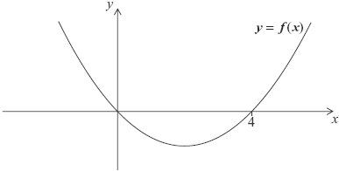

(a) Write down the solutions to the equation *f*(*x*) = 0.

(2)

(b) Write down the equation of the axis of symmetry of the graph of *f*(*x*).

(2)

(c) The equation *f*(*x*) = 12 has two solutions. One of these solutions is *x* = 6. Use the symmetry of the graph to find the other solution.

(1)

(d) The minimum value for *y* is –4. Write down the range of *f*(*x*).

(1)

(Total 6 marks)

**5.** A quadratic function, *f*(*x*)= *ax*2+ *bx*, is represented by the mapping diagram below.



(a) Use the mapping diagram to write down **two** equations in terms of *a* and *b*.

(2)

(b) Find the value of

(i) *a*;

(ii) *b*.

(2)

(c) Calculate the *x*-coordinate of the vertex of the graph of *f*(*x*).

(2)

(Total 6 marks)

**6.** The function *f*(*x*) = 5 – 3(2–*x*) is defined for *x* ≥ 0.

(a) (i) On the axes below sketch the graph of *f*(*x*) and show the behaviour of the curve as *x* increases.

(ii) Write down the coordinates of any intercepts with the axes.

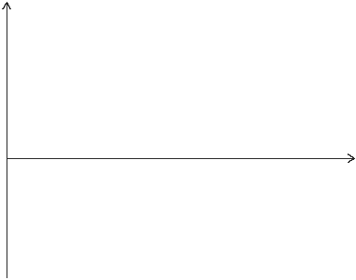

(4)

(b) Draw the line *y* = 5 on your sketch.

(1)

(c) Write down the number of solutions to the equation *f*(*x*) = 5.

(1)

(Total 6 marks)

**7.** The graph of *y* = 2*x*2– *rx* + *q* is shown for –5 ≤ *x* ≤ 7.

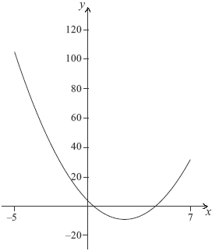

The graph cuts the *y-*axis at (0, 4).

(a) Write down the value of *q.*

(1)

The axis of symmetry is *x* = 2.5.

(b) Find the value of *r.*

(2)

(c) Write down the minimum value of *y.*

(1)

(d) Write down the range of *y.*

(2)

(Total 6 marks)

**8.** A rumour spreads through a group of teenagers according to the exponential model

*N* = 2 × (1.81)0.7*t*

where *N* is the number of teenagers who have heard the rumour *t* hours after it first started.

(a) Find the number of teenagers who started the rumour.

(2)

(b) Write down the number of teenagers who have heard the rumour 5 hours after it first started.

(1)

(c) Determine the length of time it would take for 150 teenagers to have heard the rumour. **Give your answer correct to the nearest minute.**

(3)

(Total 6 marks)

**9.** (a) Sketch the graph of *y* = 2*x* for –2 ≤ *x* ≤ 3. Indicate where this curve intersects the *y*-axis.

(3)

(b) Write down the equation of the asymptote of the graph of *y* = 2*x*.

(2)

(c) On the same axes sketch the graph of *y* = 3 + 2*x* – *x*2. Indicate where this curve intersects the *x* and *y* axes.

(3)

(d) Using your graphic display calculator, solve the equation 3 + 2*x* – *x*2 = 2*x*.

(2)

(e) Write down the maximum value of the function *f*(*x*) = 3 + 2*x* – *x*2.

(1)

(f) Use Differential Calculus to verify that your answer to (e) is correct.

(5)

(Total 16 marks)

**10.** Consider the function *f*(*x*) = *x*3 + , *x* ≠ 0.

(a) Calculate *f*(2).

(2)

(b) Sketch the graph of the function *y* = *f*(*x*) for –5≤ *x* ≤ 5 and –200 ≤ *y* ≤ 200.

(4)

(c) Find *f*′(*x*).

(3)

(d) Find *f*′(2).

(2)

(e) Write down the coordinates of the local maximum point on the graph of *f.*

(2)

(f) Find the range of *f.*

(3)

(g) Find the gradient of the tangent to the graph of *f* at *x* = 1.

(2)

There is a second point on the graph of *f* at which the tangent is parallel to the tangent at *x* = 1.

(h) Find the *x*-coordinate of this point.

(2)

(Total 20 marks)

**11.** The function *f*(*x*)is defined by *f*(*x*) = 1.5*x* + 4 + , *x* ≠ 0.

(a) Write down the equation of the vertical asymptote.

(2)

(b) Find *f*′(*x*).

(3)

(c) Find the gradient of the graph of the function at *x* = –1.

(2)

(d) Using your answer to part (c), decide whether the function *f*(*x*)is increasing or decreasing at *x* = –1. Justify your answer.

(2)

(e) Sketch the graph of *f*(*x*)for –10 ≤ *x* ≤ 10 and –20 ≤ *y* ≤ 20.

(4)

P1 is the local maximum point and P2 is the local minimum point on the graph of *f*(*x*)*.*

(f) Using your graphic display calculator, write down the coordinates of P1 and P2.

(4)

(g) Using your sketch from (e), determine the range of the function *f*(*x*)for –10 ≤ *x* ≤ 10.

(3)

(Total 20 marks)

**12.** Consider the function *f*(*x*) = *x*3 – 3*x*2 – 24*x* + 30.

(a) Write down *f*(0).

(1)

(b) Find *f*′(*x*).

(3)

(c) Find the gradient of the graph of *f*(*x*) at the point where *x* = 1.

(2)

The graph of *f*(*x*) has a local maximum point, M, and a local minimum point, N.

(d) (i) Use *f*′(*x*) to find the *x*-coordinate of M and of N.

(ii) Hence or otherwise write down the coordinates of M and of N.

(5)

(e) Sketch the graph of *f*(*x*) for –5 ≤ *x* ≤ 7 and –60 ≤ *y* ≤ 60. Mark clearly M and N on your graph.

(4)

Lines *L*1 and *L*2 are parallel, and they are tangents to the graph of *f*(*x*) at points A and B respectively. *L*1 has equation *y* = 21*x* + 111.

(f) (i) Find the *x*-coordinate of A and of B.

(ii) Find the *y*-coordinate of B.

(6)

(Total 21 marks)