**IB MATH STUDIES EXAM REVIEW: Topic 7 Markscheme**

**Rates of Change, Derivatives, Equations of Tangent and Normal Lines, Stationary Points, Increasing and Decreasing Intervals, The Second Derivative, Maxima and Minima, Optimization Problems**

**1.** (a)  (A1) (C1)

**Note:** Accept an equivalent, unsimplified expression (i.e. 2 × x).

(b) 1 (A1) (C1)

(c) *x* = 1 (M1)

*x* = 2 (A1)(ft) (C2)

**Notes:** Award (M1)(A0)for coordinate pair ( 2, –1) seen. Follow through from their answers to parts (a) and (b).

(d)  
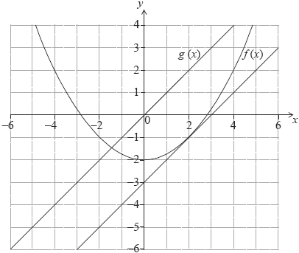  
tangent drawn to the parabola at the *x*-coordinate found in part (c) (A1)(ft)  
candidate’s attempted tangent drawn parallel to the graph of *g* (*x*) (A1)(ft) (C2)

[6]

**2.** (a) 22 × *p* ***+*** 2*q* – 4 **=** –10 (M1)

**Note:** Award (M1) for correct substitution in the equation.

4*p* ***+*** 2*q* **=** –6 or 2*p* ***+*** *q* = –3 (A1)

**Note:** Accept equivalent simplified forms.

(b) (i)  **=** 2*px* ***+*** *q* (A1)(A1)

**Note:** Award (A1) for each correct term.  
Award at most (A1)(A0) if any extra terms seen.

(ii) 4*p* ***+*** *q* = 1 (A1)(ft)

(c) 4*p* **+** 2*q* **=** –6  
4*p* **+** *q* **=** 1 (M1)

**Note:** Award (M1) for sensible attempt to solve the equations.

*p* **=** 2, *q* = –7 (A1)(A1)(ft)(G3)

[8]

**3.** (a) greater than (A1)  
Gradient between *x* **=** –2 and *x* **=** 0 is positive. (R1)

**OR**

The function is increased between these points or equivalent. (R1) (C2)

**Note:** Accept a sketch. Do not award (A1)(R0).

(b) *y* **=** 3 (A1)(A1) (C2)

**Note:** Award (A1) for y **=** a constant, (A1) for 3.

(c) minimum (A1)  
Gradient is negative to the left and positive to the right or equivalent. (R1) (C2)

**Note:** Accept a sketch. Do not award (A1)(R0).

[6]

**4.** (a) *f*′(*x*) **=** 4*x* + 1 (A1)(A1)(A1) (C3)

**Note:** Award (A1) for each term differentiated correctly.  
Award at most (A1)(A1)(A0) if any extra terms seen.

(b) *f*′(–3) **=** –11 (A1)(ft) (C1)

(c) 4*x* **+** 1 **=** 0 (M1)  
*x* =  (A1)(ft) (C2)

[6]

**5.** (a) 2*x* (A1) (C1)

(b) 3 (A1) (C1)

(c) 2*x* **=** 3 (M1)

**Note:** (M1) for equating their (a) to their (b).

*x* **=** 1.5 (A1)(ft)  
*y* **=** (1.5)2 – 4 (M1)

**Note:** (M1) for substituting their x in f(x).

(1.5, –1.75) (accept *x* **=** 1.5, *y* **=** –1.75) (A1)(ft) (C4)

**Note:** Missing coordinate brackets receive (A0) if this is the first time it occurs.

[6]

**6.** (a) *y* = 13.5*x* + 4.5 (M1)

**Note:** Award (M1) for 13.5x seen.

gradient = 13.5 (A1) (C2)

(b) 4*x*3 (A1) (C1)

(c) (i) 4*x*3 = 13.5 (M1)

**Note:** Award (M1) for equating their answers to (a) and (b).

*x* = 1.5 (A1)(ft)

(ii)  (5.0625, 5.06) (A1)(ft) (C3)

**Note:** Award (A1)(ft) for substitution of their (c)(i) into x4 with working seen.

[6]

**7.** (a) –1.10, 0.218, 3.13 (A1)(A1)(A1)

(b) *f′*(*x*) = 12*x*2 – 18*x* – 12 (A1)(A1)(A1)

**Note:** Award (A1) for each correct term and award maximum of (A1)(A1) if other terms seen.

(c) *f*′(*x*) = 0 (M1)  
*x* = –0.5, 2  
*x* = –0.5 (A1)

**Note:** If x = –0.5 not stated, can be inferred from working below.

*y* = 4(–0.5)3 – 9(–0.5)2 – 12(–0.5) + 3 (M1)  
*y* = 6.25 (A1)(G3)

**Note:** Award (M1) for their value of x substituted into f(x).  
Award (M1)(G2) if sketch shown as method. If coordinate pair given then award (M1)(A1)(M1)(A0)**.** If coordinate pair given with no working award (G2).

(d) (0, 3) (A1)

**Note:** Accept x = 0, y = 3.

(e) *f*′(0) **=** –12 (M1)(A1)(ft)(G2)

**Note:** Award (M1) for substituting x = 0 into their derivative.

(f) Tangent: *y* = –12*x* + 3 (A1)(ft)(A1)(G2)

**Note:** Award (A1)(ft) for their gradient, (A1) for intercept = 3.  
Award (A1)(A0) if y = not seen.

(g) –12 (A1)(ft)

**Note:** Follow through from their part (e).

(h) 12*x*2 – 18*x* – 12 = –12 (M1)  
12*x*2 – 18*x* = 0 (M1)  
*x* = 1.5, 0  
At Q, *x* = 1.5 (A1)(ft)(G2)

**Note:** Award (M1)(G2) for 12x2 – 18x – 12 = –12 followed by  
x = 1.5. Follow through from their part (g).

[19]

**8.** (a) 600 = π*x*2*h* (M1)(A1)  
 = *h* (AG)

**Note:** Award (M1) for correct substituted formula, (A1) for correct substitution. If answer given not shown, award at most (M1)(A0).

(b) (i) *C* =  (M1)  
*C* =  (or 1200*x*–1) (A1)

**Note:** Award (M1) for correct substitution in formula, (A1) for correct simplification.

(ii) *A* = 2π*x*2 + 1200*x*–1 (A1)(A1)(ft)

**Note:** Award (A1) for multiplying the area of the base by two, (A1) for adding on their answer to part (b)(i).  
For both marks to be awarded answer must be in terms of x.

(c)  = 4π*x* –  (A1)(ft)(A1)(ft)(A1)(ft)

**Notes:** Award (A1) for 4πx, (A1) for –1200, (A1) for x–2. Award at most (A2) if any extra term is written. Follow through from their part (b)(ii).

(d) 4π*x* –  = 0 (M1)(M1)  
*x*3 =  (or equivalent)  
*x* = 4.57 (A1)(ft)(G2)

**Note:** Award (M1) for using their derivative, (M1) for setting the derivative to zero, (A1)(ft) for answer. Follow through from their derivative. Last mark is lost if value of x is zero or negative.

(e) *A* = 2π(4.57)2 + 1200(4.57)–1 (M1)  
*A* = 394 (A1)(ft)(G2)

**Note:** Follow through from their answers to parts (b) (ii) and (d).

[14]

**9.** (a) *f*′(*x*) **=** 3 –  (A1)(A1)(A1)

**Note:** Award (A1) for 3, (A1) for –24, (A1) for x3 (or x–**3**). If extra terms present award at most (A1)(A1)(A0).

(b) *f*′(1) **=** –21 (M1)(A1)(ft)(G2)

**Note:** (ft) from their derivative only if working seen.

(c) Derivative (gradient, slope) is negative. Decreasing. (R1)(A1)(ft)

**Note:** Do not award (R0)(A1).

(d) 3 –  **=** 0 (M1)  
*x*3 **=** 8 (A1)  
*x* **=** 2 (A1)(ft)(G2)

(e) (i) (2, 9) (Accept *x* **=** 2, *y* **=** 9) (A1)(A1)(G2)

**Notes:** (ft) from their answer in (d).  
Award (A1)(A0) if brackets not included and not previously penalized.

(ii) 0 (A1)

(iii) *y* **=** 9 (A1)(A1)(ft)(G2)

**Notes:** Award (A1) for y **=** constant, (A1) for 9.  
Award (A1)(ft) for their value of y in (e)(i).

(f)

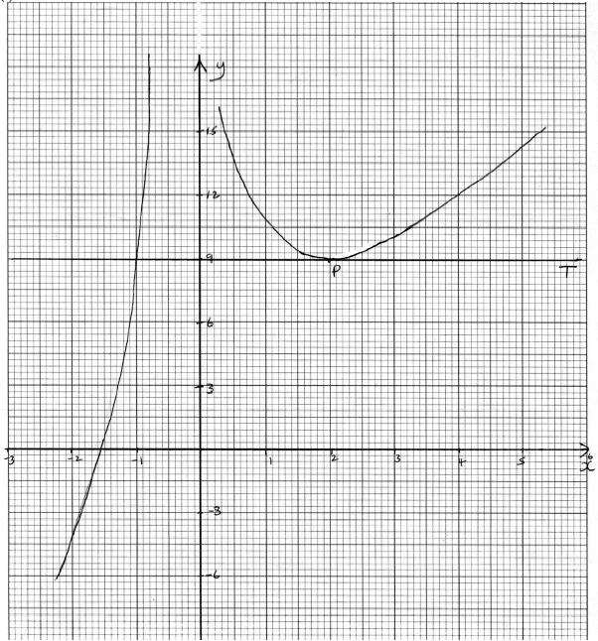

(A4)

**Notes:** Award (A1) for labels and some indication of scale in the stated window.  
Award (A1) for correct general shape (curve must be smooth and must not cross the y-axis).  
Award (A1) for x-intercept seen in roughly the correct position. Award (A1) for minimum (P).

(g) (i) Tangent drawn at P (line must be a tangent and horizontal). (A1)  
Tangent labeled *T.* (A1)

(ii) *x* **=** –l (G1)(ft)

**Note:** (ft) from their tangent equation only if tangent is drawn and answer is consistent with graph.

[22]

**10.** (a)  (M1)

Point:  (A1)

 (A1)

At ,  (M1)

Tangent gradient:  (A1)

Normal gradient:  (A1)

Normal equation:  (A1)

(b)  (M1)(G1)(G1)

[10]

**11.** (a)  (A1)(A1)

(b) , so  (M1)

 (A1)

*x* = 1 (A1)

 (M1)

 (A1)

(c) Tangent equation:  **OR**  (A1)

(d)  or  (M1)

 (A1)

(e) Normal gradient:  (A1)

Normal equation:  or  (M1)

 (A1)

(f)  and  (M1)(G1)(G1)(G1)(G1)

[18]