**IB MATH STUDIES EXAM REVIEW: Topic 6 Markscheme**

**Domain & Range, Linear Functions, Intercepts, Exponential Functions, Asymptotes, Quadratic Functions, Axis of Symmetry, Vertex, Other Functions, Maxima & Minima, Endpoints, Intersections, Accurate Graphs**

**1.** (a) *x* =  (M1)  
*x* = 2 (A1)

**OR**

 = 4 – 2*x* (M1)  
*x* = 2 (A1)

(2, 7) or *x* = 2, *y* = 7 (A1) (C3)

**Notes:** Award (M1)(A1)(A0)for 2, 7 without parentheses.

(b) (i) C labelled in correct position on graph (A1) (C1)  
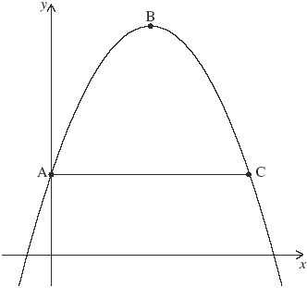

(ii) 3 = 3 + 4*x* – *x*2 (M1)

**Note:** Award (M1)for correct substitution of y = 3 into quadratic.

(*x* =) 4 (A1) (C2)

**OR**

Using symmetry of graph *x* = 2 + 2 (M1)

**Note:** Follow through from their x-coordinate of the vertex.

(*x* =) 4 (A1)(ft) (C2)

[6]

**2.** (a) *y* = 1.25 – *a*0 1.25 – 1 (M1)  
= 0.25 (A1) (C2)

**Note:** Award (M1)(A1)for (0, 0.25).

(b) 1 = 1.25 – *a*–2 (M1)  
*a* = 2 (A1) (C2)

(c) *y* = 1.25 (A1)(A1) (C2)

**Note:** Award (A1)for y = “a constant”, (A1)for 1.25.

[6]

**3.** (a) *p* ***+*** *q* **=** 6 (A1)  
0*.*5*p* ***+*** *q* **=** 4 (A1) (C2)

**Note:** Accept correct equivalent forms of the equations.

(b) *p* **=** 4, *q* = 2 (A1)(A1)(ft) (C2)

**Notes:** If both answers are incorrect, award (M1) for attempt at solving simultaneous equations.

(c) *y* **=** 2 (A1)(A1)(ft) (C2)

**Notes:** Award (A1) for “y **=** a constant”, (A1)(ft) for 2. Follow through from their value for q as long as their constant is greater than 2 and less than 6.  
An equation must be seen for any marks to be awarded.

[6]

**4.** (a) *x* **=** 0, *x* **=** 4 (A1)(A1) (C2)

**Notes:** Accept 0 and 4

(b) *x* **=** 2 (A1)(A1) (C2)

**Note:** Award (A1) for x **=** constant, (A1) for 2.

(c) *x* **=** –2 (A1) (C1)

**Note:** Accept –2

(d) *y* ≥ –4 (*f*(*x*) ≥ –4) (A1) (C1)

**Notes:** Accept alternative notations.  
Award (A0) for use of strict inequality.

[6]

**5.** (a) 4*a* *+* 2*b* = 20  
*a* + *b* = 8 (A1)  
*a* – *b* = –4 (A1) (C2)

**Note:** Award (A1)(A1) for any two of the given or equivalent equations.

(b) (i) *a* = 2 (A1)(ft)

(ii) *b* = 6 (A1)(ft) (C2)

**Note:** Follow through from their (a).

(c) *x* =  (M1)

**Note:** Award (M1) for correct substitution in correct formula.

= –1.5 (A1)(ft) (C2)

[6]

**6.** (a) (i)  
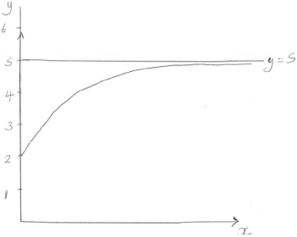 (A1)(A1)(A1)

**Notes:** Award (A1) for labels and scale on y-axis.  
Award (A1) for smooth increasing curve in the given domain.  
Award (A1) for asymptote implied (gradient → 0).

(ii) (0*,* 2) (accept *x* **=** 0***,*** *y* **=** 2) (A1) (C4)

**Note:** If incorrect domain used and both (0, 2) and (–0.737, 0) seen award (A1)(ft).

(b) line passing through (0, 5), parallel to *x*-axis and not intersecting  
their graph. (A1) (C1)

zero (A1) (C1)

[6]

**7.** (a) *q* **=** 4 (A1) (C1)

(b) 2.5 =  (M1)

*r* **=** 10 (A1) (C2)

(c) –8.5 (A1)(ft) (C1)

(d) –8.5 ≤ *y* ≤ 104 (A1)(ft)(A1)(ft) (C2)

**Notes:** Award (A1)(ft) for their answer to part (c) with correct inequality signs, (A1)(ft) for 104. Follow through from their values of q and r. Accept 104 **±**2 if read from graph.

[6]

**8.** (a) *N* **=** 2 ×(1.81)0.7×0 (M1)  
*N* **=** 2 (A1) (C2)

**Notes:** Award (M1) for correct substitution of t **=** 0.  
Award (A1) for correct answer.

(b) 16.0 (3 s.f.) (A1) (C1)

**Note:** Accept 16 and 15.

(c) 150 **=** 2 × (1.81)0.7*t* (M1)  
*t* **=** 10.39... h (A1)  
*t* **=** 624 minutes (A1)(ft) (C3)

**Notes:** Accept 10 hours 24 minutes. Accept alternative methods.  
Award last (A1)(ft) for correct rounding to the nearest minute of their answer. Unrounded answer must be seen so that the follow through can be awarded.

[6]

**9.** (a)  
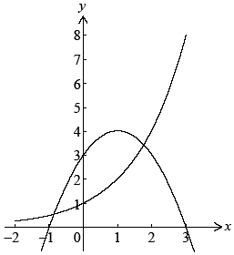 (A1)(A1)(A1)

**Note:** Award (A1) for correct domain, (A1) for smooth curve, (A1) for y-intercept clearly indicated.

(b) *y* **=** 0 (A1)(A1)

**Note:** Award (A1) for y **=** constant, (A1) for 0.

(c) ***Note:*** *Award (A1) for smooth parabola,  
(A1) for vertex (maximum) in correct quadrant.  
(A1) for all clearly indicated intercepts x* ***=*** *–1, x* ***=*** *3 and y* ***=*** *3.  
The final mark is to be applied very strictly.* (A1)(A1)(A1)

(d) *x* **=** –0.857 *x* **=** 1.77 (G1)(G1)

**Note:** Award a maximum of (G1) if x and y coordinates are both given.

(e) 4 (G1)

**Note:** Award (G0) for (1, 4).

(f) *f*′(*x*) **=** 2 – 2*x* (A1)(A1)

**Note:** Award (A1) for each correct term.  
Award at most (A1)(A0) if any extra terms seen.

2 – 2*x* **=** 0 (M1)

**Note:** Award (M1) for equating their gradient function to zero.

*x* **=** 1 (A1)(ft)  
*f*(1) **=** 3 **+** 2(1) – (1)2 **=** 4 (A1)

**Note:** The final (A1) is for substitution of x **=** 1 into f(x) and subsequent correct answer. Working must be seen for final (A1) to be awarded.

[16]

**10.** (a) *f* (2) = 23 +  (M1)  
= 32 (A1)(G2)

(b)  
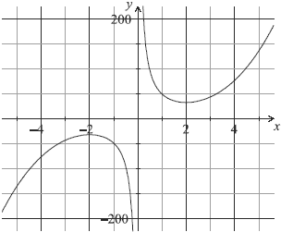  
(A1)for labels and some indication of scale in an appropriate window  
(A1)for correct shape of the two unconnected and smooth branches  
(A1)for maximum and minimum in approximately correct positions  
(A1)for asymptotic behaviour at *y*-axis (A4)

**Notes:** Please be rigorous. The axes need not be drawn with a ruler. The branches must be smooth: a single continuous line that does not deviate from its proper direction. The position of the maximum and minimum points must be symmetrical about the origin. The y-axis must be an asymptote for **both** branches. Neither branch should touch the axis nor must the curve approach the asymptote then deviate away later.

(c) *f*′(*x*) = 3*x*2 –  (A1)(A1)(A1)

**Notes:** Award (A1)for 3x2, (A1)for –48, (A1)for x–2.  
Award a maximum of (A1)(A1)(A0)if extra terms seen.

(d) *f*(2*)* = 3(2)2 –  (M1)

**Note:** Award (M1)for substitution of x = 2 into their derivative.

= 0 (A1)(ft)(G1)

(e) (–2,–32) or *x* = *–*2, *y* = –32 (G1)(G1)

**Notes:** Award (G0)(G0)for x = –32, y = –2  
Award at most (G0)(G1)if parentheses are omitted.

(f) {*y* > 32}  {*y* < –32} (A1)(A1)(ft)(A1)(ft)

**Notes:** Award (A1)(ft)y **>** 32 or y > 32 seen, (A1)(ft)for  
y ≤–32 or y < –32, (A1)for weak (non-strict) inequalities used in both of the above.  
Accept use of f in place of y. Accept alternative interval notation.  
Follow through from their (a) and (e).  
If domain is given award (A0)(A0)(A0).  
Award (A0)(A1)(ft)(A1)(ft)for [–200, –32], [32, 200].  
Award (A0)(A1)(ft)(A1)(ft)for ]–200, –32], [32, 200[.

(g) *f*′(1) = –45 (M1)(A1)(ft)(G2)

**Notes:** Award (M1)for f(1) seen or substitution of x = 1 in their derivative. Follow through from their derivative if work is seen.

(h) *x* = –1 (M1)(A1)(ft)(G2)

**Notes:** Award (M1)for equating their derivative to their –45 or for seeing parallel lines on their graph in the approximately correct position.

[20]

**11.** (a) *x* = 0 (A1)(A1)

**Note:** Award (A1)for x = constant, (A1)for 0.

(b) *f*′(*x*) = 1.5 –  (A1)(A1)(A1)

**Notes:** Award (A1)for 1.5, (A1)for –6, (A1)for x–2  
Award (A1)(A1)(A0)at most if any other term present.

(c) 1.5 –  (M1)  
= –4.5 (A1)(ft)(G2)

**Note:** Follow through from their derivative function.

(d) Decreasing, the derivative (gradient or slope) is negative (at *x* = –1) (A1)(R1)(ft)

**Notes:** Do not award (A1)(R0).  
Follow through from their answer to part (c).

(e)  
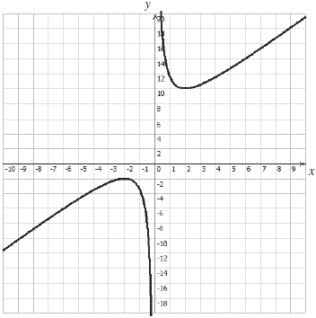 (A4)

**Notes:** Award (A1)for labels and some indication of scales and an appropriate window. Award (A1)for correct shape of the two unconnected, and smooth branches.  
Award (A1)for the maximum and minimum points in the approximately correct positions. Award (A1)for correct asymptotic behaviour at x = 0.

**Notes:** Please be rigorous.  
The axes need not be drawn with a ruler.  
The branches must be smooth and single continuous lines that do not deviate from their proper direction.  
The max and min points must be symmetrical about point (0, 4).  
The y-axis must be an asymptote for **both** branches.

(f) local maximum P1 (–2, – 2) (G1)(G1)

local minimum P2 (2, 10) (G1)(G1)

(g) {–2 ≥ *y*} or {*y* ≥ 10} (A1)(A1)(ft)(A1)

**Notes:** (A1)(ft)for y > 10 or y **≥** 10  
(A1)(ft)for y < –2 or y ≤ –2  
(A1)for weak (non-strict) inequalities used in **both** of the above.  
Follow through from their (e) and (f).

[20]

**12.** (a) 30 (A1)

(b) *f*′(*x*) **=** 3*x*2 – 6*x* – 24 (A1)(A1)(A1)

**Note:** Award (A1) for each term. Award at most (A1)(A1) if extra terms present.

(c) *f*′(1) **=** –27 (M1)(A1)(ft)(G2)

**Note:** Award (M1) for substituting x **=** 1 into their derivative.

(d) (i) *f*′(*x*) **=** 0  
3*x*2 – 6*x* – 24 **=** 0 (M1)  
*x* **=** 4; *x* **=** –2 (A1)(ft)(A1)(ft)

**Notes:** Award (M1) for either f′(x) **=** 0 or 3x2 – 6x – 24 **=** 0 seen.  
Follow through from their derivative.  
Do not award the two answer marks if derivative not used.

(ii) M(–2, 58) accept *x* **=** –2*,* *y* **=** 58 (A1)(ft)  
N(4, –50) accept *x* **=** 4, *y* **=** –50 (A1)(ft)

**Note:** Follow through from their answer to part (d) (i).

(e)  
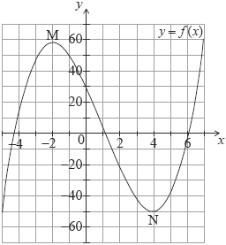  
(A1) for window  
(A1) for a smooth curve with the correct shape  
(A1) for axes intercepts in approximately the correct positions  
(A1) for M and N marked on diagram and in approximately  
correct position (A4)

**Note:** If window is not indicated award at most (A0)(A1)(A0)(A1)(ft).

(f) (i) 3*x*2 – 6*x* – 24 **=** 21 (M1)  
3*x*2 – 6*x* – 45 **=** 0 (M1)  
*x* **=** 5; *x* **=** –3 (A1)(ft)(A1)(ft)(G3)

**Note:** Follow through from their derivative.

**OR**

Award (A1) for *L*1 drawn tangent to the graph of *f* on their (A1)(ft)  
sketch in approximately the correct position (*x* **=** –3),  
(A1) for a second tangent parallel to their *L*1, (A1)(ft)  
(A1) for *x* **=** –3, (A1) for *x* **=** 5. (A1)(A1)

**Note:** If only x **=** –3 is shown without working award (G2).  
If both answers are shown irrespective of working award (G3).

(ii) *f*(5) **=** **–**40 (M1)(A1)(ft)(G2)

**Notes:** Award (M1) for attempting to find the image of their x **=** 5. Award (A1) only for (5, – 40).  
Follow through from their x-coordinate of B **only** **if** **it** **has** **been** **clearly** **identified** in (f) (i).

[21]