**IB MATH STUDIES EXAM REVIEW: Topic 4 Markscheme**

**Chi-Squared Test, Correlation Coefficient, Line of Best Fit, Normal Distribution**

**1.** (a) customer satisfaction is **independent** of café (A1)

**Note:** Accept “customer satisfaction is **not associated with** the café”.

(b) 2 (A1)

(c) 0.754 (G2)

**Note:** Award (G1)(G1)(AP)for 0.75 or for correct answer incorrectly rounded to 3 s.f. or more, (G0)for 0.7.

(d) since *χ*2*calc* < *χ*2*crit* (5.991) accept (or Do not reject) H0 (R1)(A1)(ft)

**Note:** Follow through from their value in (e).

**OR**

Accept (or Do not reject) H0 as *p*-value (0.686) > 0.05 (R1)(A1)(ft)

**Notes:** Do not award (A1)(R0).  
Award the (R1) for comparison of appropriate values.

[6]

**2.** (a) H0 : Choice of language is independent of gender. (A1)

**Notes:** Do not accept “not related” or “not correlated”.

(b) 2 (A1)

(c)  = 23 (M1)(A1)(G2)

**Notes:** Award (M1)for correct substituted formula, (A1)for 23.

(d) *χ*2 = 4.77 (G2)

**Notes:** If answer is incorrect, award (M1)for correct substitution in the correct formula (all terms).

(e) Accept H0 since  
 (5.99) **or** *p*-value (0.0923) > 0.05 (R1)(A1)(ft)

**Notes:** Do not award (R0)(A1).  
Follow through from their (d) and (b).

[8]

**3.** (a)

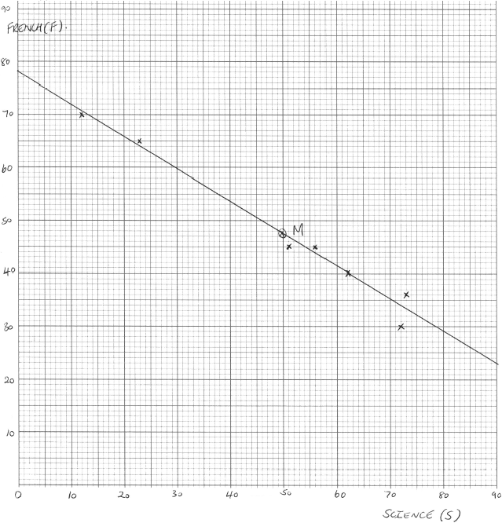

Award (A1)for correct scale and labels.  
Award (A3)for all seven points plotted correctly,  
(A2)for 5 or 6 points plotted correctly,  
(A1)for 3 or 4 points plotted correctly. (A4)

(b) (i)  = 49.9 (G1)

(ii)  = 47.3 (G1)

(c) M(49.9, 47.3) plotted on scatter diagram (A1)(ft)

**Notes:** Follow through from (a) and (b).

(d) *F* = –0.619*S* + 78.2 (G1)(G1)

**Notes:** Award (G1)for –0.619S, (G1)for 78.2.  
If the answer is not in the form of an equation, award (G1)(G0).  
Accept y = –0.619x + 78.2

**OR**

F – 47.3 = –0.619(S– 49.9) (G1)(G1)

**Note:** Award (G1)for –0.619, (G1)for the coordinates of their midpoint used. Follow through from their values in (b).

(e) line drawn on scatter diagram (A1)(ft)(A1)(ft)

**Notes:** The drawn line **must** be straight for any marks to be awarded. Award (A1)(ft)passing through their M plotted in (c).  
Award (A1)(ft)for correct y-intercept. Follow through from their y-intercept found in (d).

(f) *F*= –0.619 × 44 + 78.2 (M1)  
= 51.0 (allow 51 or 50.9) (A1)(ft)(G2)(ft)

**Note:** Follow through from their equation.

**OR**

(M1)any indication of an acceptable graphical method. (M1)  
(A1)(ft)from their regression line. (A1)(ft)(G2)(ft)

(g) not reliable (A1)  
Monique’s score in Science is outside the range of scores used  
to create the regression line. (R1)

**Note:** Do not award (A1)(R0).

[15]

**4.** (a)

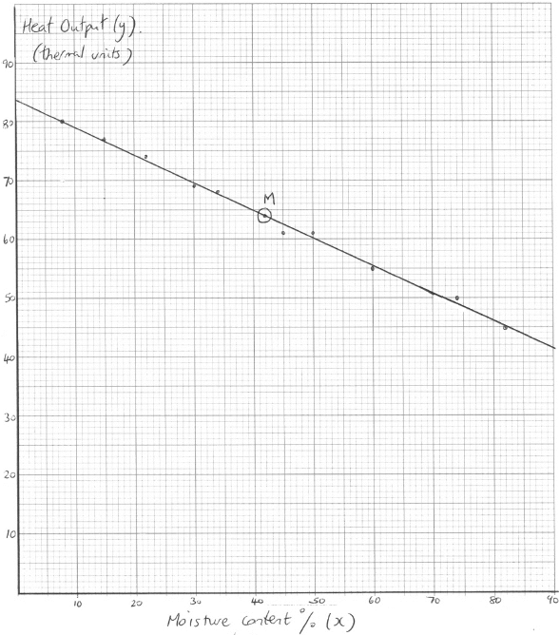

(A1)for correct scales and labels

(A3)for all ten points plotted correctly, (A2)for eight or nine points plotted correctly, (A1)for six or seven points plotted correctly (A4)

**Note:** Award at most (A0)(A3)if axes reversed.

(b) (i)  = 42 (A1)

(ii)  = 64 (A1)

(c)  plotted on graph and labelled, M (A1)(ft)(A1)

**Note:** Award (A1)(ft)for position, (A1)for label.

(d) –0.998 (G2)

**Note:** Award (G1)for correct sign, (G1)for correct absolute value.

(e) line on graph (A1)(ft)(A1)

**Notes:** Award (A1)(ft)for line through M, (A1)for correct y-intercept between 83 and 85. It is not necessary that the line is seen to intersect the y-axis. The line must be straight for any mark to be awarded.

(f) *y* = –0.470(25) + 83.7 (M1)

**Note:** Award (M1)for substitution into formula or indication of method on their graph. y = –0.470(0.25) + 83.7 is incorrect.

= 72.0 (accept 71.95 and 72) (A1)(ft)(G2)

**Note:** Follow through from graph only if they show working on their graph. Accept 72 ±0.5.

(g) Yes since 25 % lies within the data set and *r* is close to –1 (R1)(A1)

**Note:** Accept Yes, since r is close to –1.

**Note:** Do not award (R0)(A1).

[16]

**5.** (a) Normal distribution with mean of 65 and standard deviation of 9.

normcdf (80, 1099, 65, 9) (M1)

= 0.478 **OR** 4.78% (A1)

(b) P (finishing race in less than 60 minutes) = normcdf (–1099, 60, 65, 9) (M1)

= 0.289257… (A1)

 (M1)

= 1446 runners (accept 1445 runners or 1450 runners) (A1)

(c)  so 20% of the runners finish before Simon. (A1)

InvNorm (0.2, 65, 9) (M1)

= 57.4 minutes (A1)

[9]

**6.** (a) (i) normalpdf (2.8, 3.4, 3, 0.2) = 81.9% (M1)(A1)

(ii) normalpdf (–1099, 2.91, 3, 0.2) = 32.6% (M1)(A1)

**Note:** Award (A0)(A1)for answers given as decimals instead of percentages.

(b) P (weighed more than 3.1 kg) = normcdf (3.1, 1099, 3, 0.2) (M1)

= 0.308537… (A1)

 (M1)

= 185 babies (A1)

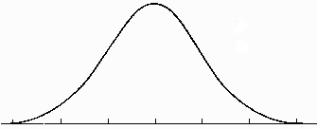(c) (i)

18%



(A1)(A1)

**Notes:** Award (A1) for the shape of the curve and a vertical line to the right of the mean, and (A1)for shading to the right of the vertical line and labeling the shaded region as 18% or 0.18.

(ii) 18% of the babies are heavier than *k*, so 82% are lighter than *k* (A1)

InvNorm (0.82, 3, 0.2) (M1)

= 3.18 kg (A1)

[13]