**IB MATH STUDIES EXAM REVIEW: Topic 3 Markscheme**

**Logical Symbols, Truth Tables, Tautologies, Contradictions, Equivalences, Converse, Inverse, Contrapositive, Sets, Venn Diagrams, Probability, Tree Diagrams, Mutual Exclusivity, Independence, Conditional Probability**

**1.** (a) –4, –3, –2, –1, 0, 1, 2 (A1) (C1)

**Note:** Award (A1)for correct numbers, do not penalise if braces, brackets or parentheses seen.

(b)  (0.571, 57.1%) (A1)(ft)(A1)(ft) (C2)

**Notes:** Award (A1)(ft)for numerator, (A1)(ft)for denominator.  
Follow through from part (a).There is no further penalty in parts (c) and (d) for use of denominator consistent with that in part (b).

(c)  (0.143, 14.3%) (A1)(ft) (C1)

**Note:** Follow through from part (a).

(d)  (0.143, 14.3%) (A1)(ft)(A1)(ft) (C2)

**Note:** Award (A1)(ft)for numerator, (A1)(ft)for denominator.  
Follow through from part (a).

[6]

**2.** (a)  ¬*q* (A1)(A1)(A1) (C3)

**Note:** Award (A1)for two conjunctions, (A1)for negation seen on q, (A1)for correct compound statement.

(b) If I visited (either) Sarah’s Snackbar **or** Pete’s Eats (then) I  
did not visit Alan’s Diner (A1)(A1)(A1) (C3)

**Note:** Award (A1)for If… (then), (A1)for Sarah’s Snackbar **or** Pete’s Eats, (A1)for did not visit Alan’s Diner.

[6]

**3.** (a)  
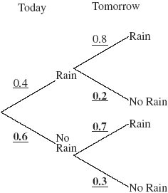 (A1)(A1)(A1) (C3)

**Note:** Award (A1)for each correct pair.

(b) 0.4 × 0.8 + 0.6 × 0.7 (A1)(ft)(M1)

**Notes:** Award (A1)(ft)for two consistent products from tree diagram, (M1)for addition of their products. Follow through from their tree diagram provided all probabilities are between 0 and 1.

= 0.74 (A1)(ft) (C3)

[6]

**4.** (a) 1 (one) (A1) (C1)

**Note:** 6, {6} or {1} earns no marks.

(b) 1, 3, 5, 7, 9, 11 (A1) (C1)

**Note:** Do not penalise if braces, parentheses or brackets are seen.

(c)  
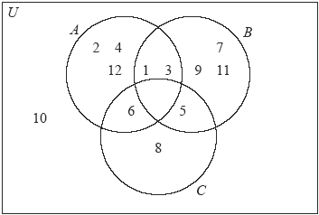

(A1)(A1)(ft)(A1)(ft)(A1)(ft) (C4)

**Notes:** Award (A1)for the empty set .  
Award (A1)(ft)for the correct placement of 6, 5, 1 and 3.  
Award (A1)(ft)for the correct placement of 2, 4, 12, 7, 9, 11, 8.  
Award (A1)(ft)for the correct placement of 10.  
Follow through from part (b).

[6]

**5.** (a) If I do not choose history then I choose either psychology or I  
choose art (A1)(A1)(A1) (C3)

**Notes:** Award (A1)for ‘if…(then)…’  
Award (A1)for ‘not choose history.’  
Award (A1)for ‘choose (either) psychology or art (or both).’  
If the order of the statements is wrong award at most (A1)(A1)(A0)

(b)

|  |  |  |  |
| --- | --- | --- | --- |
| *a* | *p* | ¬*a* | ¬*a*  *p* |
| T | T | F | **T** |
| T | F | F | **T** |
| F | T | T | **T** |
| F | F | T | **F** |

(A1) (C1)

(c) Neither, because not all the entries in the last column are the same (A1)(ft)(R1) (C2)

**Notes:** Do not award (R0)(A1).  
Follow through from their answer to part (b).  
Reasoning must be consistent with their answer to part (b).

[6]

**6.** (a)  (A1)(A1) (C2)

**Note:** Award (A1)for numerator, (A1)for denominator.

(b)  (0.236, 23.6%) (A1)(A1) (C2)

**Note:** Award (A1)for numerator, (A1)for denominator.

(c)  (0.418, 41.8%) (A1)(A1) (C2)

**Note:** Award (A1)for numerator, (A1)for denominator.

[6]

**7.** (a)  
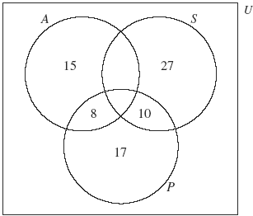  
(A1)for rectangle and three labelled intersecting circles  
(A1)for 15, 27 and 17  
(A1)for 10 and 8 (A3)

(b) 48–(8 + 10 + 17) *or equivalent* (M1)  
= 13 (A1)(ft)(G2)

(c) 50 – (27 + 10 + 13) (M1)

**Note:** Award (M1)for working seen.

= 0 (A1)  
number of elements in A = 36 (A1)(ft)(G3)

**Note:** Follow through from (b).

(d) 21 (A1)(ft)

**Note:** Follow through from (b) even if no working seen.

(e) 54 (M1)(A1)(ft)(G2)

**Note:** Award (M1)for 17, 10, 27 seen. Follow through from (a).

(f)  (A1)(A1)(G2)

**Note:** Award (A1)for numerator, (A1)for denominator.

(g)  (A1)(A1)(G2)

**Note:** Award (A1)for numerator, (A1)for denominator.

(h)  (A1)(A1)(G2)

**Note:** Award (A1)for numerator, (A1)for denominator.

[17]

**8.** (a) (i) *If the number ends in zero then it is divisible by 5* (A1)

(ii) *If the number is divisible by 5 then it ends in zero* (A1)

(b) (i) ¬*p*  ¬*q* (A1)

(ii) ¬*q*  ¬*p* (A1)

[4]