Name, Block and Date:______________________________________
Practice Test for the 2nd Unit of Stats Measures of central Tendency and Measures of Spread
1. A random sample of 18 airline carry-on luggage bags gave the following weights (rounded to the nearest pound).
12 25 10 38 12 19 8 12 17
41 7 22 10 19 12 16 5 14
Find the mean, median, and mode of these weights.

2. A random sample of 7 Northern Pike from Taltson Lake (Canada) gave the following lengths rounded to the nearest inch.
21 27 46 35 41 36 25
(a) Find the range. 3.
(b) Find the sample mean.
(c) Find the sample variance.
(d) Find the sample standard deviation.

3. A random sample of receipts for individuals eating at the Terrace Restaurant showed the sample mean to be x = $10.38 with sample standard deviation s = $2.17.
Compute the coefficient of variation for this data.

4. A random sample of 330 adults were asked the maximal amount (dollars) they would spend on a ticket to a top rated performance.
The results follow where x is the cost and f is the number of people who would spend that maximal amount.
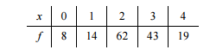

(a) Compute the sample mean.
(b) Compute the sample variance.
(c) Compute the sample standard deviation.
5. A random sample of 27 skiers at Vail, Colorado gave their ages. The results were
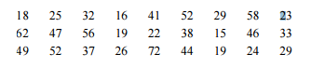

(a) Give the five number summary including the low value
Q1, median, Q3 and high value.
(b) Make a box-and-whisker plot for the given data.
(c) Find the interquartile range.

6. In Biology 340, weights are assigned to required activities as follows:
project, 25%; exam 1, 15%; exam 2, 15%; exam 3, 15%; final exam, 30%
Each activity is graded on a 100 point scale. Gary earned 75 points on the project, 85 points on exam 1, 95 points on exam 2, 90 points on exam 3, and 88 points on the final exam. Compute his overall
weighted average in the Biology 340 class.

7. Lifestyles Weight-loss Clinic gave the following information about the distribution of its clients. Estimate the weighted average of the weight (in pounds) of a client.
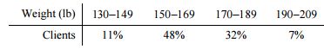

8. Sophia took a test and scored in the 79th percentile. What percentage of the scores were at or below her score? What percentage were above?

