**IB MATH STUDIES EXAM REVIEW: Topic 1**

**Rounding, Scientific Notation, Percent Error, Currency Conversion, Compound Interest, Arithmetic and Geometric Sequences and Series, Solving Systems of Linear Equations, Solving Quadratic Equations**

**1.** Given *p* = *x*–, *x* = 1.775, *y* = 1.44 and *z* = 48,

(a) calculate the value of *p.*

(2)

Barry **first** writes *x,* *y* and *z* correct to one significant figure and **then** uses these values to estimate the value of *p.*

(b) (i) Write down *x,* *y* and *z* each correct to one significant figure.

(ii) Write down Barry’s estimate of the value of *p.*

(2)

(c) Calculate the percentage error in Barry’s estimate of the value of *p.*

(2)

(Total 6 marks)

**2.** A satellite travels around the Earth in a circular orbit 500 kilometres above the Earth’s surface.  
The radius of the Earth is taken as 6400 kilometres.

(a) Write down the radius of the satellite’s orbit.

(1)

(b) Calculate the distance travelled by the satellite in one orbit of the Earth, to the nearest km.

(3)

(c) Write down your answer to (b) in the form *a* × 10*k*, where 1≤ *a* < 10, *k*  .

(2)

(Total 6 marks)

**3.** A manufacturer in England makes 16 000 garden statues. 12 % are defective and cannot be sold.

(a) Find the number of statues that are non-defective.

(2)

The manufacturer sells each non-defective statue for 5.25 British pounds (GBP) to an American company. The exchange rate from GBP to US dollars (USD) is 1 GBP = 1.6407 USD.

(b) Calculate the amount in USD paid by the American company for all the non-defective statues. Give your answer correct to **two decimal places**.

(2)

The American company sells one of the statues to an Australian customer for 12 USD.  
The exchange rate from Australian dollars (AUD) to USD is 1 AUD = 0.8739 USD.

(c) Calculate the amount that the Australian customer pays, in AUD, for this statue.  
Give your answer correct to **two decimal places**.

(2)

(Total 6 marks)

**4.** A teacher earns an annual salary of 45 000 USD for the first year of her employment  
Her annual salary increases by 1750 USD each year.

(a) Calculate the annual salary for the fifth year of her employment.

(3)

She remains in this employment for 10 years.

(b) Calculate the **total** salary she earns in this employment during these 10 years.

(3)

(Total 6 marks)

**5.** The diagram shows the straight lines *L*1 and *L*2. The equation of *L*2 is *y* = *x*.

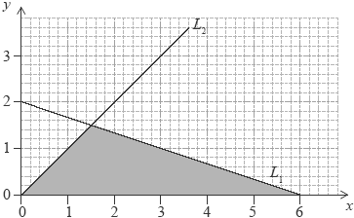

(a) Find

(i) the gradient of *L*1;

(ii) the equation of *L*1.

(3)

(b) Find the area of the shaded triangle.

(3)

(Total 6 marks)

**6.** The seventh term, *u*7, of a geometric sequence is 108. The eighth term, *u*8, of the sequence is 36.

(a) Write down the common ratio of the sequence.

(1)

(b) Find *u*1.

(2)

The sum of the first *k* terms in the sequence is 118 096.

(c) Find the value of *k.*

(3)

(Total 6 marks)

**7.** The equation of the line *R*1 is 2*x* + *y* – 8 = 0. The line *R*2 is perpendicular to *R*1.

(a) Calculate the gradient of *R*2.

(2)

The point of intersection of *R*1 and *R*2 is (4, *k*).

(b) Find

(i) the value of *k*;

(ii) the equation of *R*2.

(4)

(Total 6 marks)

**8.** 10 000 people attended a sports match. Let *x* be the number of adults attending the sports match and *y* be the number of children attending the sports match.

(a) Write down an equation in *x* and *y.*

(1)

The cost of an adult ticket was 12 AUD. The cost of a child ticket was 5 AUD.

(b) Find the total cost for a family of 2 adults and 3 children.

(2)

The total cost of tickets sold for the sports match was 108 800 AUD.

(c) Write down a second equation in *x* and *y.*

(1)

(d) Write down the value of *x* and the value of *y.*

(2)

(Total 6 marks)

**9.** In the diagram,  = 90°. The length of the three sides are *x* cm, (*x* + 7) cm and (*x* + 8) cm.

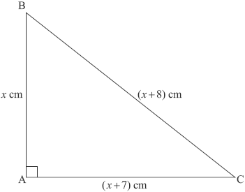

(a) Write down and **simplify** a quadratic equation in *x* that links the three sides of the triangle.

(3)

(b) Solve the quadratic equation found in part (a).

(2)

(c) Write down the value of the perimeter of the triangle.

(1)

(Total 6 marks)

**10.** Consider the arithmetic sequence 1, 4, 7, 10, 13, …

(a) Find the value of the eleventh term.

(2)

(b) The sum of the first *n* terms of this sequence is (3*n* – 1).

(i) Find the sum of the first 100 terms in this arithmetic sequence.

(ii) The sum of the first *n* terms is 477.

(a) Show that 3*n*2– *n* – 954 = 0.

(b) Using your graphic display calculator or otherwise, find the number of terms, *n.*

(6)

(Total 8 marks)

**11.** **Give all answers in this question correct to two decimal places.**

Estela lives in Brazil and wishes to exchange 4000 BRL (Brazil reals) for GBP (British pounds). The exchange rate is 1.00 BRL = 0.3071 GBP. The bank charges 3 % commission on the amount in BRL.

(a) Find, **in BRL**, the amount of money Estela has after commission.

(2)

(b) Find, in GBP, the amount of money Estela receives.

(2)

After her trip to the United Kingdom Estela has 400 GBP left. At the airport she changes this money back into BRL. The exchange rate is now 1.00 BRL = 0.3125 GBP.

(c) Find, in BRL, the amount of money that Estela should receive.

(2)

Estela actually receives 1216.80 BRL after commission.

(d) Find, in BRL, the commission charged to Estela.

(1)

(e) The commission rate is *t* %. Find the value of *t*.

(2)

(Total 9 marks)

**12.** A geometric sequence has 1024 as its first term and 128 as its fourth term.

(a) Show that the common ratio is .

(2)

(b) Find the value of the eleventh term.

(2)

(c) Find the sum of the first eight terms.

(3)

(d) Find the number of terms in the sequence for which the **sum** first exceeds 2047.968.

(3)

(Total 10 marks)

**13.** Pauline owns a piece of land ABCD in the shape of a quadrilateral. The length of BC is 190 m, the length of CD is 120 m, the length of AD is 70 m, the size of angle BCD is 75° and the size of angle BAD is 115°.

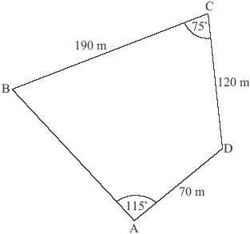

***diagram not to scale***

Pauline decides to sell the triangular portion of land ABD. She first builds a straight fence from B to D.

(a) Calculate the length of the fence.

(3)

The fence costs 17 USD per metre to build.

(b) Calculate the cost of building the fence. Give your answer correct to the nearest USD.

(2)

(c) Show that the size of angle ABD is 18.8°, correct to three significant figures.

(3)

(d) Calculate the area of triangle ABD.

(4)

She sells the land for 120 USD per square metre.

(e) Calculate the value of the land that Pauline sells. Give your answer correct to the nearest USD.

(2)

Pauline invests 300 000 USD from the sale of the land in a bank that pays compound interest compounded annually.

(f) Find the interest rate that the bank pays so that the investment will double in value in 15 years.

(4)

(Total 18 marks)